船用门窗盖梯业绩表
Door&window&cover Achievement
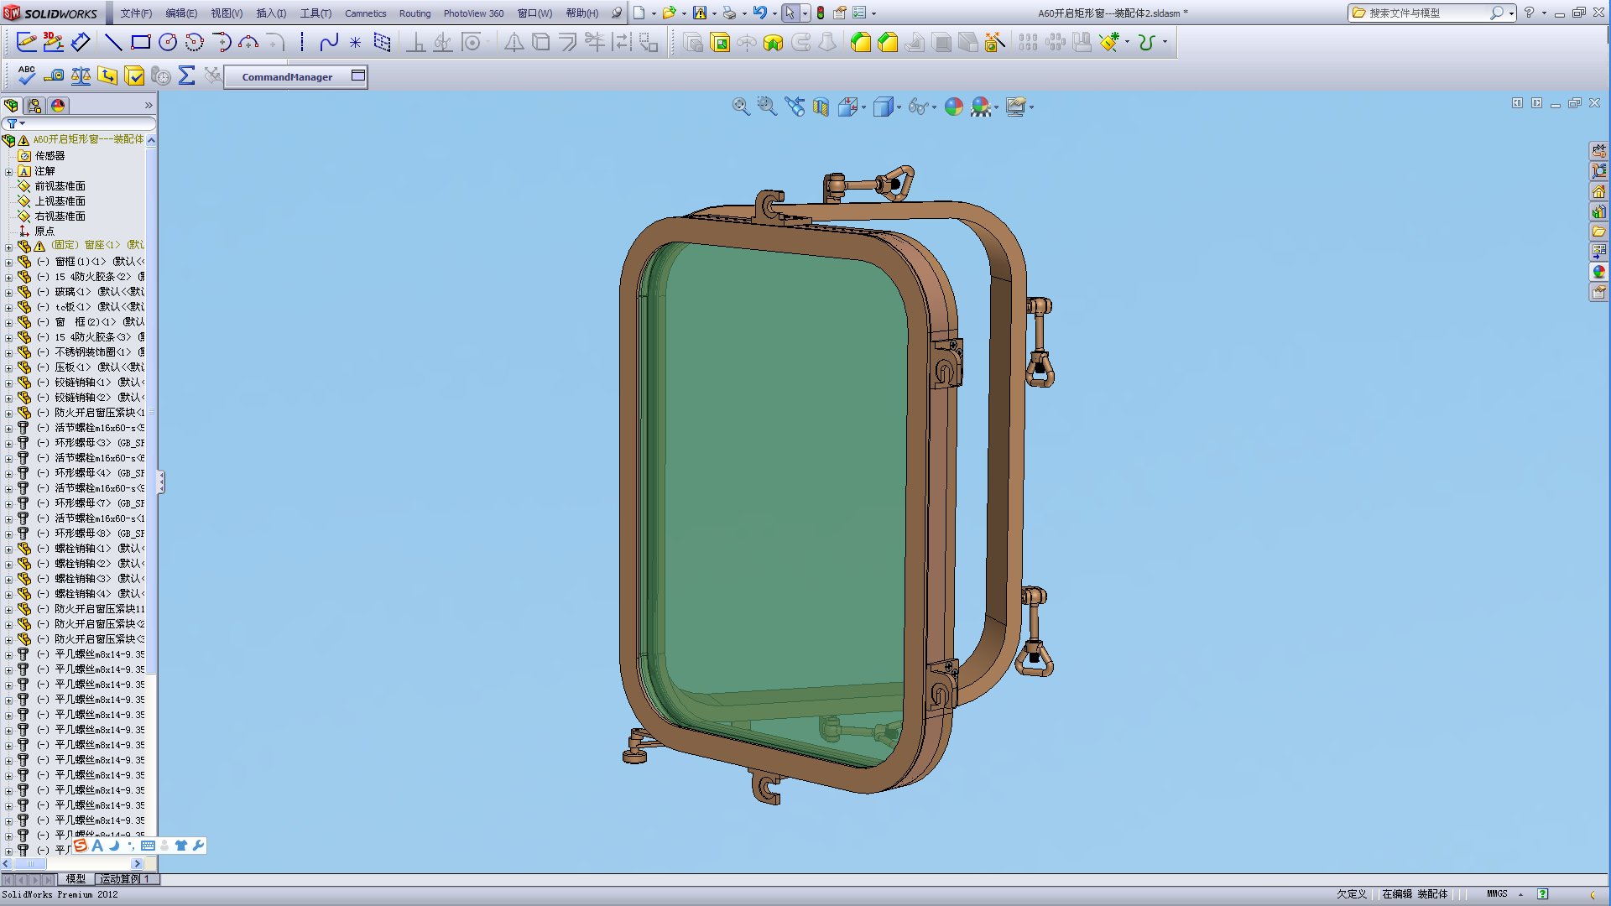
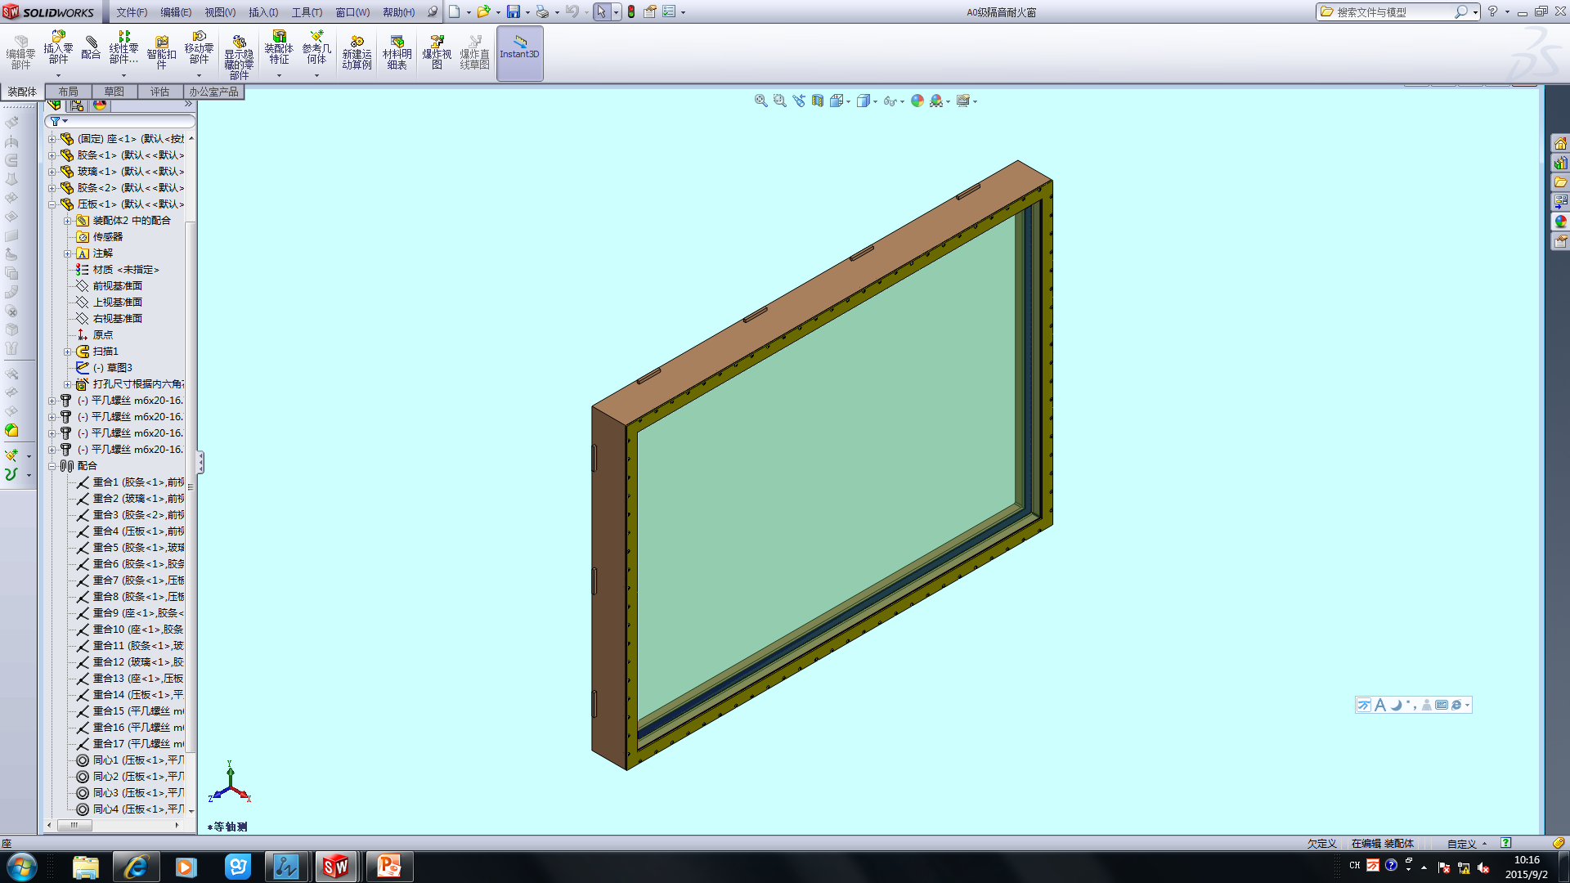
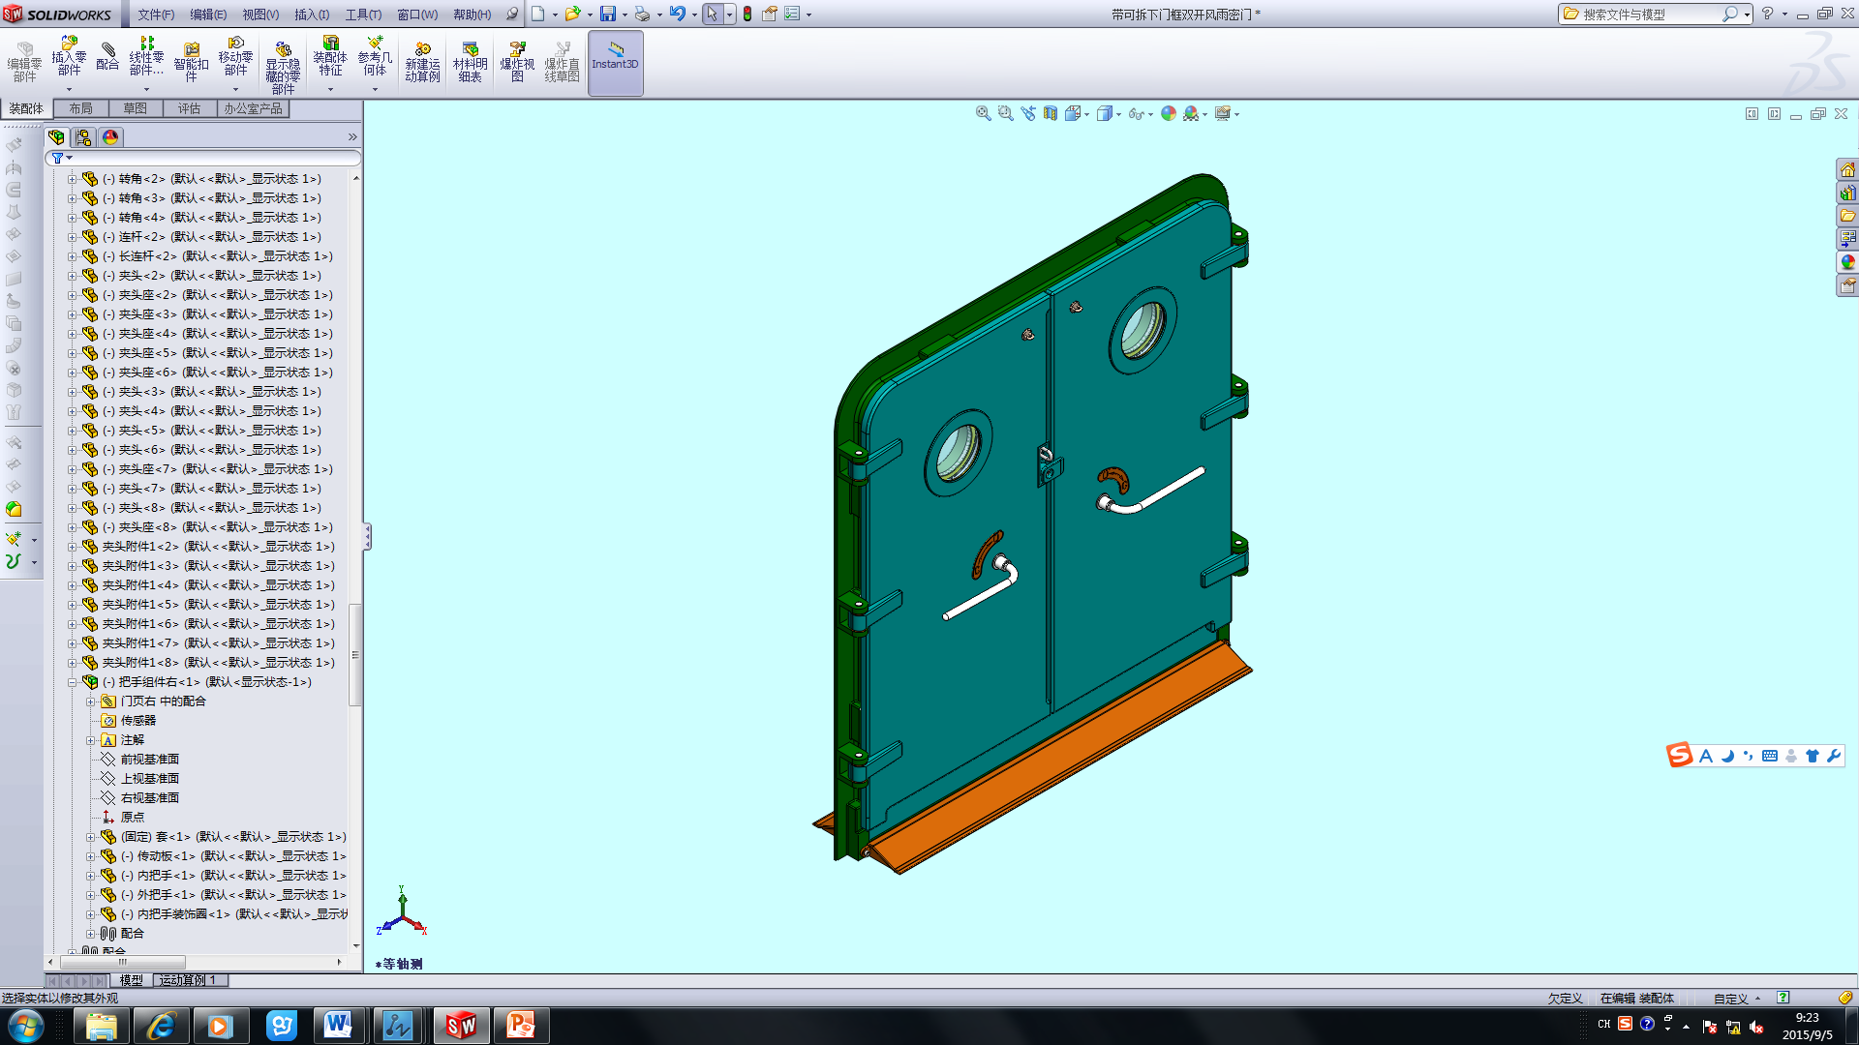
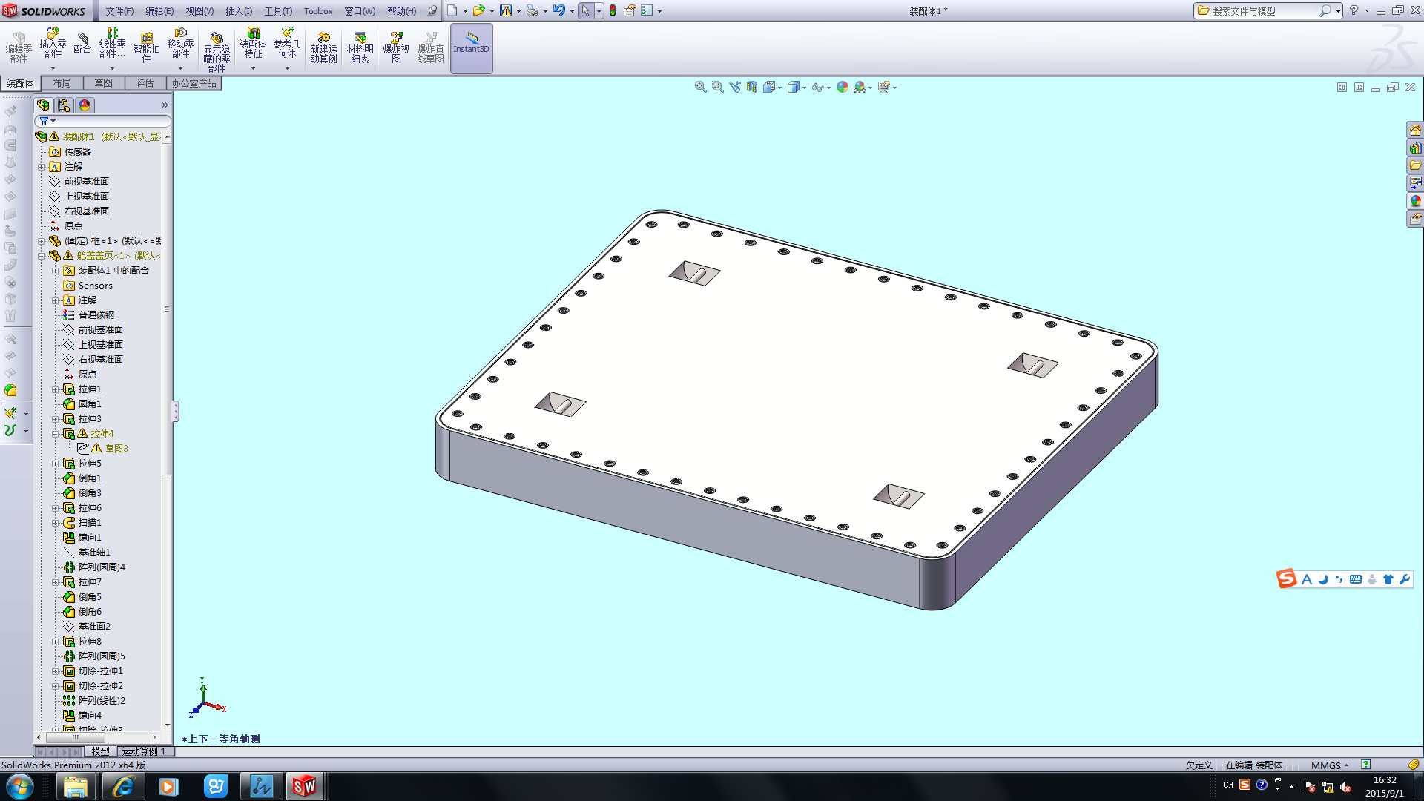
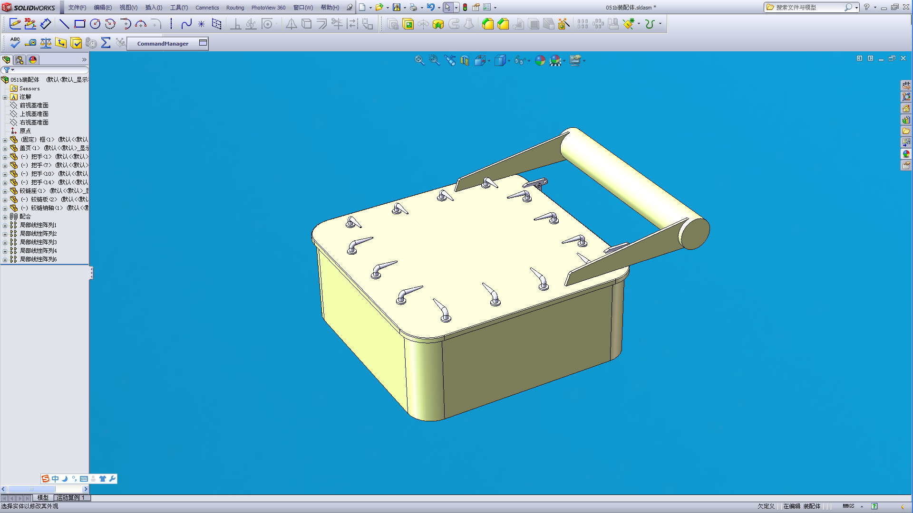

无锡市东舟船舶设备股份有限公司
Wuxi Dongzhou Marine Equipment Co. LTD.

序号  No. | 船 厂  Shipyard | 船名/船号  Hull Name/Hull No. | 产品名称  Product Name | 备注  Remark
1 | 上海外高桥  Shanghai Waigaoqiao shipbuiliding Co., Ltd. | 海洋石油981、CJ46-X100-D平台  Offshore oil 981, CJ46-X100-D platform | 船用门、窗、盖  等舾装件  Marine door, window, cover and other fittings | 满足船检要求，可分别取得LR、BV、ABS、DNV-GL、CCS等证书  LR, BV, ABS, DNV-GL, CCS and other certificates can be obtained respectively to meet the requirements of ship inspection
2 | 上海船厂  Shanghai shipyard Co., Ltd. | 4000箱集装箱船，12000HP、8002、8004、海洋石油721 S8003、6000 KW 拖轮、地质勘探船-A、地质勘探船-B、  4000TEU Container ships, 12000HP, 8002, 8004, offshore oil 721 S8003, 6000KW tug, geological exploration ship -A, geological exploration ship -B | 船用门、窗、盖  等舾装件  Marine door, window, cover and other fittings
3 | 上海江南船厂  Shanghai jiangnan shipyard | 新雪龙号、10000吨海监船1#、2#（防弹玻璃、防弹门）  New snow dragon, 10,000 tons marine surveillance ship 1#, 2# (bullet-proof glass, bullet-proof door) | 船用门、窗、盖  等舾装件  Marine door, window, cover and other fittings
4 | 上海振华  Shanghai Zhenhua Heavy Industry Co. LTD | 4500T大型抢险打捞起重船、铺管船、DLV4400、15000HP三用工作船、78m三用工作船、100003 挖泥船  4500T large salvage crane ship, pipe laying vessel, DLV4400 15000HP AHTS, 78m AHTS and 100003 dredger | 船用门、窗、盖  等舾装件  Marine door, window, cover and other fittings
5 | 4805工厂  4805 Factory | 护卫舰、3600吨化学品船  Frigate, 3,600 tons chemical tanker | 船用门、窗、盖  等舾装件  Marine door, window, cover and other fittings
6 | 人民解放军第四八零八工厂  People's liberation army 4808 factory | 60T拖轮  60T tug | 船用门、窗、盖  等舾装件  Marine door, window, cover and other fittings
7 | 上海沪东船厂  Hudong-Zhonghua shipbuiliding Co., Ltd. | 渔业资源调查船  Fishery resources survey ship | 船用门、窗、盖  等舾装件  Marine door, window, cover and other fittings
8 | 招商局重工  CMHI(Jiangsu) Co.,Ltd. | CJ46-X100-D平台、163-1\2  CJ46-X100-D platform、163-1\2 | 船用门、窗、盖  等舾装件  Marine door, window, cover and other fittings
9 | 南通中远川崎重工船厂  Nantong COSCO KHI Ship Engineering Co., Ltd. | 36000DWT散货船  36000 DWT bulk carrier | 船用门、窗、盖  等舾装件  Marine door, window, cover and other fittings

序号  No. | 船 厂  Shipyard | 船名/船号  Hull Name/Hull No. | 产品名称  Product Name | 备注  Remark
10 | 鼎衡（江苏）船厂  AVIC Dingheng shipbuiliding Co., Ltd. | 12000 m3液化气船、6500m3液化气船、17500吨化学品船  12,000m3 liquefied gas tanker, 6500m3 liquefied gas tanker, 17,500 ton chemical tanker | 船用门、窗、盖  等舾装件  Marine door, window, cover and other fittings | 满足船检要求，可分别取得LR、BV、ABS、DNV-GL、CCS等证书  LR, BV, ABS, DNV-GL, CCS and other certificates can be obtained respectively to meet the requirements of ship inspection
11 | 泰州口岸船厂  Taizhou kouan shipbuilding Co., Ltd. | 45车/ 999客滚客船、紫荆12#、51000吨 散货船、38000吨 散货船、  45 car / 999 ro-ro passenger redbud 12#, 51,000 tons bulk carriers, 38, 000 tons bulk carriers | 船用门、窗、盖  等舾装件  Marine door, window, cover and other fittings
12 | 泰州三福船厂  Taizhou Sanfu shipbuilding Co., Ltd. | 51000吨 散货船、2400箱集装箱  51,000 tons bulk carriers and 2,400 containers | 船用门、窗、盖  等舾装件  Marine door, window, cover and other fittings
13 | 南京长江油运公司紫金山船厂  Nanjing Changjiang tanker Zijinshan Co., Ltd. | 2640KW 拖轮、1000吨油船  2640KW tug, 1000 ton oil tanker | 船用门、窗、盖  等舾装件  Marine door, window, cover and other fittings
14 | 长航集团金陵船厂  Sinotrans & CSC Jinling shipyard | 51000DWT 散货船、49500DWT 散货船、2500箱集装箱、1900箱集装箱、  51000DWT bulk carrier, 49500DWT bulk carrier, 2500 containers and 1,900 containers | 船用门、窗、盖  等舾装件  Marine door, window, cover and other fittings
15 | 长航集团江东船厂  Sinostrans &CSC Jiangdong shipyard | 800车滚装船、850车滚装船、1000车滚装船  800 car ro-ro ship, 850 car ro-ro ship, 1000 car ro-ro ship | 船用门、窗、盖  等舾装件  Marine door, window, cover and other fittings
16 | 中船澄西船厂  CSSC Chengxi shipyard Co., Ltd. | 65000吨散货船、48500吨散货船、  65,000 tons bulk carriers, 48,500 tons bulk carriers | 船用门、窗、盖  等舾装件  Marine door, window, cover and other fittings
17 | 江苏熔盛重工  Jiangsu Rongsheng Heavy Industry Co., Ltd. | H1088铺管船  H1088 pipelaying ship | 船用门、窗、盖  等舾装件  Marine door, window, cover and other fittings
18 | 黄海船厂  Huanghai Shipyard | 10000 KW 拖轮  10000KW tug | 船用门、窗、盖  等舾装件  Marine door, window, cover and other fittings

序号  No. | 船 厂  Shipyard | 船名/船号  Hull Name/Hull No. | 产品名称  Product Name | 备注  Remark
19 | 黄海船厂  Huanghai Shipyard | 海洋渔船、1500P/2700M客滚船、1500P/1400M客滚船、2000P/1600M客滚船、2500P/2300M客滚船、1080P/2480M客滚船、1500P/2500M客滚船、1200客客滚船、11000DWT多用途工作船、78m渔船/钓鱼船、南极磷虾船、溢油回收船  Seagoing fishing vessel, 1500P/2700M ro-ro passenger ship, 1500P/1400M ro-ro passenger ship, 2000P/ 1600M ro-ro passenger ship, 2500P/2300M ro-ro passenger ship, 1080P/ 2480M ro-ro passenger ship, 1500P/ 2500M ro-ro passenger ship, 1200 passenger ro-ro passenger, 11000DWT multi-purpose vessel, 78M fishing boats/angling boat, Antarctic krill ship, oil spill recovery ship | 船用门、窗、盖  等舾装件  Marine door, window, cover and other fittings | 满足船检要求，可分别取得LR、BV、ABS、DNV-GL、CCS等证书  LR, BV, ABS, DNV-GL, CCS and other certificates can be obtained respectively to meet the requirements of ship inspection
20 | 蓬莱中柏京鲁船厂  Penglai Zhongpai Jinglu shipyard | 1000吨渔政船、70.8m渔船、76m渔船/钓鱼船、5800吨油轮、77m渔船/钓鱼船  1000 tons fishery administration ship, 70.8m fishing boats, 76m fishing boats/angling boat, 5,800 tons oil tanker, and 77m fishing boats/angling boat | 船用门、窗、盖  等舾装件  Marine door, window, cover and other fittings
21 | 青岛船厂  Qingdao shipyard | 2600HP 拖轮、2940KW 拖轮  2600HP tug, 2940KW tug | 船用门、窗、盖  等舾装件  Marine door, window, cover and other fittings
22 | 武昌船厂  Wuchang Shipbuilding Industry group Co.,Ltd. | 1460KW 拖轮、海监船52#、991# 试验船、5500HP 巡逻舰、2000m3 挖泥船、11000KW 拖轮、16000KW 拖轮、16000KW海洋平台工作船、9000KW 拖轮  1460KW tug, Marine surveillance ship 52#, 991# surveillance ship, the 5500HP patrol ship, 2000m3 dredger, 11000KW tug, 16000KW tug, 16000KW platform working ship, 9000KW tug | 船用门、窗、盖  等舾装件  Marine door, window, cover and other fittings

序号  No. | 船 厂  Shipyard | 船名/船号  Hull Name/Hull No. | 产品名称  Product Name | 备注  Remark
23 | 重庆川东造船厂  Chongqing Chuandong shipyard | 3600吨化学品船、9000吨化学品船、3750吨化学品船、1000吨渔政船  3,600 tons chemical tanker, 9,000 tons chemical tanker, 3,750 tons chemical tanker, 1,000 tons fishery administration ship | 船用门、窗、盖  等舾装件  Marine door, window, cover and other fittings | 满足船检要求，可分别取得LR、BV、ABS、DNV-GL、CCS等证书  LR, BV, ABS, DNV-GL, CCS and other certificates can be obtained respectively to meet the requirements of ship inspection
24 | 广州中船黄埔造船有限公司  Guangzhou CSSC Huangpu Shipyard Co.,Ltd. | 小水线双体船、8000KW拖轮、14000KW拖轮、12000KW拖轮、65000DWT散货船、向阳红14#、4000吨海监船、南海环保船、8000HP油田守护船、6500HP油田守护船、36000DWT散货船、8000HP三用工作船  Small waterline catamaran, 8000KW tug, 14000KW tug, 12000KW tug, 65000DWT bulk carrier, Xiangyanghong # 14, 4000tons Marine surveillance ship, the south China sea environmental protection ship, 8000HP oilfield guarding ship, 6500HP oilfield guarding ship, 36000DWT bulk carrier, 8000HP AHTS | 船用门、窗、盖  等舾装件  Marine door, window, cover and other fittings
25 | 广州文冲船厂  Guangzhou Wenchong Shipyard Co.,Ltd | 16888m3 挖泥船、13500m3 挖泥船、11888 m3 挖泥船、9500 m3 挖泥船、10000 m3 挖泥船、15000 m3 挖泥船、85m 挖泥船、6000 m3 挖泥船、18000 m3 挖泥船、10288 m3 挖泥船、南极磷虾船、6000KW 挖泥船、7200 m3 挖泥船、6000HP三用工作船  16888m3 dredger, 13500m3 dredger, 11888m3 dredger, 9500m3 dredger, 10000m3 dredger, 15000m3 dredger, 85m dredger, 6000m3 dredger, 18000m3 dredger, 10288m3 dredger, Antarctic krill ship, 6000kw dredger, 7200m3 dredger, 6000HP AHTS | 船用门、窗、盖  等舾装件  Marine door, window, cover and other fittings

序号  No. | 船 厂  Shipyard | 船名/船号  Hull Name/Hull No. | 产品名称  Product Name | 备注  Remark
26 | 广东中远船务工程有限公司  Guangdong Cosco shipping Engineering Co. LTD. | 8000HP三用工作船、65m三用工作船、  8000HP AHTS, 65m AHTS | 船用门、窗、盖  等舾装件  Marine door, window, cover and other fittings | 满足船检要求，可分别取得LR、BV、ABS、DNV-GL、CCS等证书  LR, BV, ABS, DNV-GL, CCS and other certificates can be obtained respectively to meet the requirements of ship inspection
27 | 广船国际股份有限公司  Guangzhou Shipyard International Co.,Ltd | 50000DWT散货船、3000T渔政船、GOTLAND ROPAX 1600  50000DWT bulk carrier, 3000T fishery administration ship, GOTLAND ROPAX 1600 | 船用门、窗、盖  等舾装件  Marine door, window, cover and other fittings
28 | 福建东南船厂  Fujian Southeast shipbuilding Co., Ltd. | 65M锚作供应船、65m 三用工作船、68m 海底支持船  65M anchor supply ship, 65M AHTS 68m subsea support vessel | 船用门、窗、盖  等舾装件  Marine door, window, cover and other fittings
29 | 湛江4804船厂  Zhanjiang 4804 shipyard | 2600HP 拖轮  2600HP tug | 船用门、窗、盖  等舾装件  Marine door, window, cover and other fittings
30 | 招商局(深圳)船厂  CMHI(Shenzhen) Co.,Ltd. | 30000吨自航半潜式船、50000吨自航半潜式船  30, 000 tons self-propelled semi submerged ship 50, 000 tons self-propelled semi-submerged ship | 船用门、窗、盖  等舾装件  Marine door, window, cover and other fittings
31 | 厦门船厂  Xiamen shipyard | 51000吨散货船、2400箱集装箱、1000 吨渔政船  51,000 ton bulk carriers, 2,400TEU containers 1,000 tons fishery administration ship | 船用门、窗、盖  等舾装件  Marine door, window, cover and other fittings

